Table
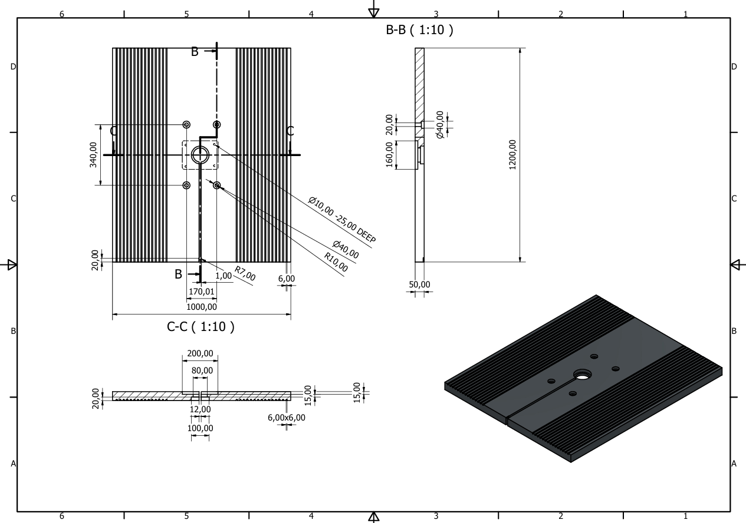

Figure 1 Table Working Drawing

MATERIAL PREPARATION

Raw Material Procurement
  - Material: Cast Iron (e.g., Grade FG 260 or equivalent)
  - Procure cast iron block/plate with sufficient oversize for finishing.

Rough Shaping (if required)
  - If the raw casting is not pre-shaped, you may consider wire EDM or plasma cutting for preliminary shaping.
  - Optional: Get the blank shape cast directly in a foundry to minimize machining.

NON-CONVENTIONAL MACHINING STEPS

1. Profile Cutting
- Method: Wire EDM (Electrical Discharge Machining)
- Use: For cutting the external profile and slots.
- Reason: Wire EDM offers excellent precision and is suitable for hard materials like cast iron.

2. Hole Machining
- Method: Electrical Discharge Machining (EDM) Drilling or Laser Drilling
- Use: For Ø6 mm, Ø10 mm, or other small holes as per drawing.
- Note: Use die-sinking EDM for deeper, non-through holes.

3. Internal Features & Pocketing
- Method: Sinker EDM
- Use: To create internal square pockets, curved features (e.g., R7), or special contours not reachable by wire EDM.
- Electrode: Graphite or copper electrode shaped as per the cavity.

4. Surface Finishing
- Method: Lapping or Electrochemical Polishing
- Use: Achieve smoothness and dimensional accuracy of flat surfaces.

POST-PROCESSING & INSPECTION

Deburring
  - Method: Abrasive Flow Machining or Ultrasonic Cleaning
  - Remove micro-burrs or residue from EDM.

Stress Relieving
  - Method: Thermal Treatment
  - Optional for dimensional stability.

Dimensional Inspection
  - Tool: CMM (Coordinate Measuring Machine)
  - Check dimensions, tolerances, flatness, and hole positions.

Manufacturing Process with Non-Conventional Machines table
Step | Method | Machine Used
Raw Material Prep | Foundry / Plasma / EDM | Casting / EDM table
Profile Cutting | Wire EDM | CNC Wire EDM Machine
Hole Drilling | EDM Drilling / Laser | EDM Hole Drilling Unit
Cavity/Slot Cutting | Sinker EDM | Die-sinking EDM
Finishing & Polishing | Electrochemical / Lapping | Electro-polisher / Lapper
Cleaning & Deburring | Abrasive Flow / Ultrasonic | Ultrasonic Cleaner
Dimensional Inspection | Metrology | CMM

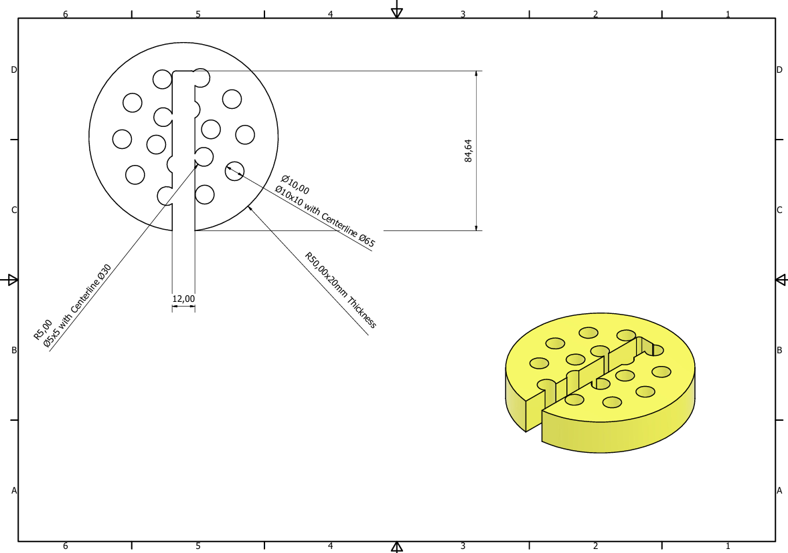
Dust port 1 :

Figure 2 Dust Port 1

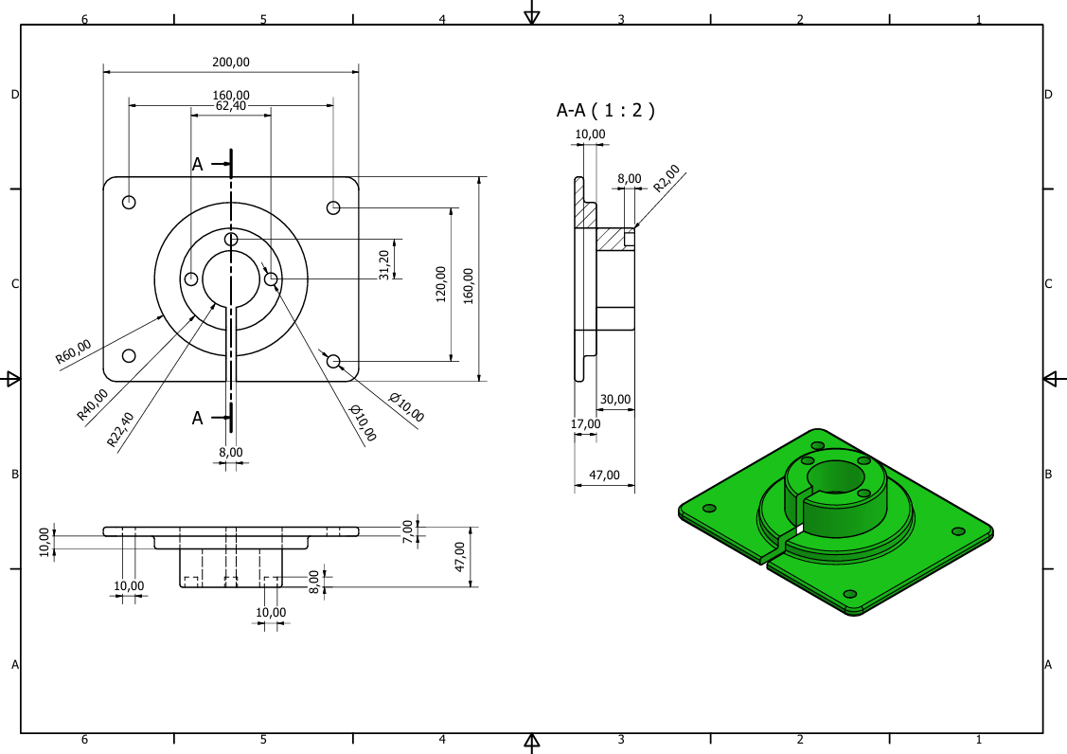
Dust Port 2 :

Figure 3 Dust Port 2

RAW MATERIAL PREPARATION

Raw Material Procurement
Material Selection: Steal 42
Blank Preparation: Cut a raw block using plasma cutting or water jet cutting (for 2D blank shaping).

ROUGH SHAPING AND OUTLINE CUTTING

Profile Cutting (Outer and Internal Contours):
  - Method: Wire EDM is excellent for intricate contours and high precision on hard materials.
  - Use: Cut the outer shape and internal cutouts (like circular/oval ports, slots).

MACHINING INTERNAL FEATURES

Holes and Cylindrical Pockets:
  - Method: EDM Drilling for deep or narrow holes.
  - Use: All internal Ø10, Ø30, Ø65, Ø5x5 holes.
  - Advantage: Excellent for small-diameter and deep holes without tool wear.

Cavities and Recesses:
  - Method: Sinker EDM (Die-Sinking EDM)
  - Use: To create internal pockets, recessed slots, or tapered holes.
  - Electrode: Graphite or copper machined to match the cavity profile.

FINISHING OPERATIONS

Edge Deburring:
  - Method: Abrasive Flow Machining or Electropolishing
  - Purpose: Remove burrs and smooth internal edges left by EDM.

Surface Finishing :
  - Method: Electrochemical Polishing or Ultrasonic Finishing
  - Use: For smoother surface texture and corrosion resistance.

HOLE ALIGNMENT & MARKING

Alignment of Centerlines & Feature Precision:
  - Inspection: Coordinate Measuring Machine (CMM) or laser scanners
  - Correction: Use EDM re-machining for fine adjustment if misalignment exists.

POST-MACHINING

Cleaning:
  - Method: Ultrasonic Cleaning
  - Purpose: Remove EDM oil residues, graphite dust, and metallic particles.

Stress Relieving (Optional):
  - Method: Low-temperature heat treatment
  - Use: To relieve internal stresses post-EDM.
Manufacturing Process with Non-Conventional Machines table
Step | Method | Machine Used
Blank Cutting | Water Jet / Plasma | CNC Water Jet
Profile & Cutouts | Wire EDM | Wire EDM Machine
Hole Machining | EDM Drilling / Sinker EDM | Hole Popper / Die-Sinker
Internal Features | Sinker EDM | Die-Sinking EDM
Deburring | Abrasive Flow / Electropolish | Flow Machining Tool
Surface Finishing | Electro-polishing | Electro-polisher
Dimensional Accuracy | CMM | CMM Machine
Marking | Laser Engraving | Fiber Laser Marker
Cleaning | Ultrasonic Cleaning | Ultrasonic Bath
Stress Relief (Optional) | Thermal Chamber | Heat Treatment Furnace

Dust Collector in Band Saws
Band saws are essential woodworking and metalworking machines used for making precise cuts. However, their operation generates a significant amount of dust and debris, which can pose health risks to operators, reduce machine efficiency, and compromise worksite cleanliness. To address these issues, dust collectors are integrated with or attached to band saws.

The primary function of a dust collector in a band saw is to:
- Extract sawdust and fine particles generated during cutting.
- Improve air quality in the workshop.
- Enhance visibility and precision while cutting.
- Extend machine life by preventing dust accumulation in moving parts.
- Ensure compliance with workplace safety and environmental regulations.

Benefits of Using a Dust Collector
- Health and Safety: Reduces the risk of respiratory issues and fire hazards.
- Clean Work Environment: Keeps the workspace free from sawdust.
- Improved Machine Performance: Prevents clogging and mechanical wear.
- Productivity: Allows better visibility and precision in cuts.
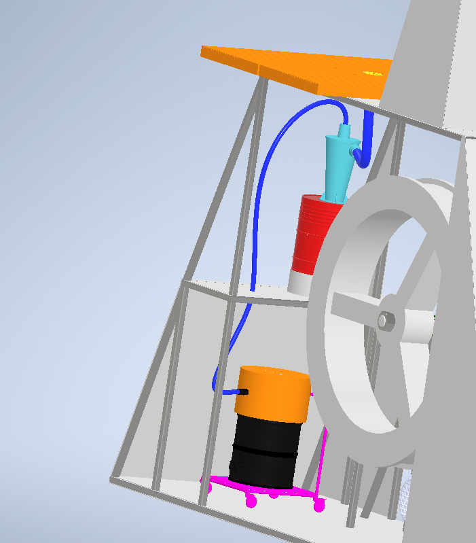
- Regulatory Compliance: Meets occupational health and safety standards.
Figure 4 Dust Collection System Assembly

Components of a Dust Collection System
A typical dust collection system for a band saw includes:
- Dust port: An opening near the blade or table area where dust is captured.
- Hoses
- Dust collector unit
- Cyclone Dust Collectors

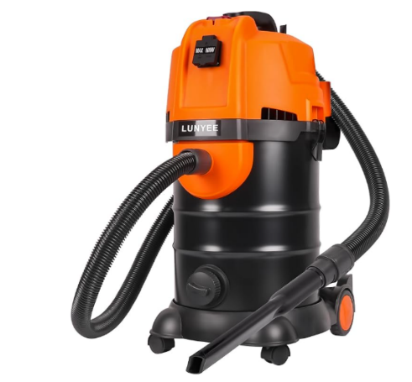
Dust collector unit
Figure 5 LUNYEE Dust Extractor Unit
the LUNYEE 7.9GAL Dust Extractor combines powerful performance, advanced filtration, user-friendly features, and durable construction, making it a compelling choice for woodworking professionals and enthusiasts seeking an efficient and reliable dust collection solution.
More Details
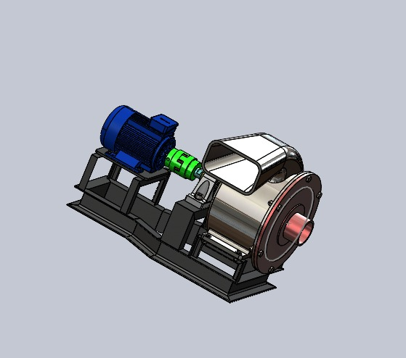
We can replace it with A blower that has High Suction Power(CFM)
Figure 6 High CFM Blower

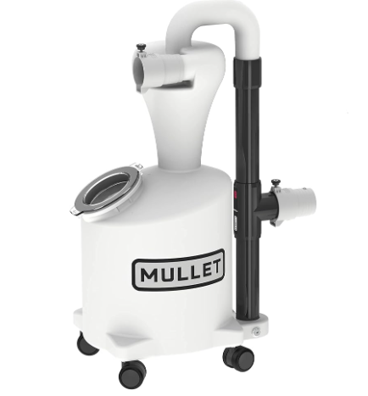
Cyclone Dust Collectors
These system separates heavy particles from fine dust using a cyclonic action before reaching the filter, increasing efficiency and filter life.
Figure 7 Mullet High-Speed Cyclone Dust Collector
We choose Mullet High-Speed Cyclone Dust Collector as it contains
- Filter: Captures fine particles and prevents them from returning to the air.
- Collection bin or bag: Stores larger particles and debris.
More Details

